Benny Iko

5/25/2021

SWEN 603 9040 Modern Software Methodologies

Waterfall methodology critique

The Waterfall methodology is the traditional five step process for creating software upon which other methodologies are based. The five main tasks are: analysis, design, implementation, testing and maintenance. Another variation includes an additional step for installation. This software development process embodies many advantages as well as disadvantages due to its overwhleming emphasis on structure. Careful attention should be paid to the characteristics of a potential project to ensure that application of this SDLC will be more beneficial than harmful. Many projects can benefit from this approach, but it is not a one size fits all solution. When considering this software life cycle, decision makers should pose questions about the project involving schedule, control, order, documentation and maintenance. For further reference, please see the table listed below from Modern Software Methodologies.
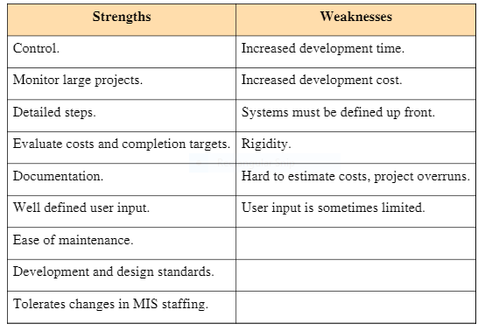

The level of care, and attention to detail is perfectly tailored for customers who desire this level of clarity throughout the life of the project. PRoject managers can exhibit extensive control over the process. The input of one phase is the output of the previous phase. There are often many signatures and documents required to progress from one step to the next. The steps are detailed, costs are evaluated and project milestones are set. Consequently, this makes the project easier to track, and can inform managers of when the project is at risk for going over budget. Design and implementation stages are conceptually more effective, because so much attention is paid to requirements up front. Any design or implementation details are put on hold until a formal system requirements (SRS) document is finalized. Integration and testing ensues after implementation. This tedious process is better suited for a lengthy project, than one with multiple iterations. Essentially there are only 5 steps; when implemented effectively, the production of well documented, thoroughly tested software is achieved as a result of an ordered and methodical process.

The rigidity of the steps involved with traditional implementation of this SDLC may have unintended consequences. Setbacks are commonplace in software engineering, but some are more costly than others. For example, many Waterfall projects tend to go over budget and schedule. The culprit is often incomplete and insufficient requirements. The same structure which is beneficial, is often harmful. Many customers have little idea what a software product is capable of. Also, few customers and end users know what they want/need in a software product let alone how to articulate it. Since requirements are gathered initially, when problems are encountered later down the road after design and implementation it becomes costly to make changes after the fact. This flaw opened the door for alternatives. Critics of this methodology propose more “agile” solutions; that is software life cycles which focus on the customer and are more accepting of change. Another benefit of other approaches is the ability to see a prototype or progress. This instant gratification is something Waterfall is lacking, but a necessary component in the modern world. Software where the customers require a quick return on investment or immediate results would not see a benefit from a project that was managed using this style. Not all projects require this, but it is impossible to see such a thing with a traditional Waterfall approach, simply because code isn’t even generated until later in the process around the implementation phase.

Not all projects are well suited to be handled by this software development methodology. Projects that benefit from this approach exhibit a particular set of characteristics. Longer, complex projects where cost is not much of a concern see benefit from the extensive amount of paperwork and documentation. In this situation, getting the product right is of utmost importance. In house corporate software would likely be managed using the Waterfall methodology. This situation also may be an environment where having a working prototype early is unnecessary, and the planning documents suffice.

The Waterfall methodology traditionally contains five steps, but some modifications include a 6th step for installation. Other common modifications account for the issues that arise later in the development process due to “big design up front”. Many Agile adoptions better address problems with requirements by making this task an ongoing process that more effectively involves the customer. This software development process embodies many advantages as well as disadvantages relative to its application. Many projects can benefit from this approach, but it is not a one size fits all solution. It is imperative to consider project length and complexity, desired level of control, order of operations , necessary documentation and post deployment maintenance. Long, complex projects where budget is not priority, and that require meticulous paperwork thrive under this process. Like any methodology, the project’s success is greatly determined by the proper gathering of requirements.

